Extension lecture by Dr. Balwant Singh

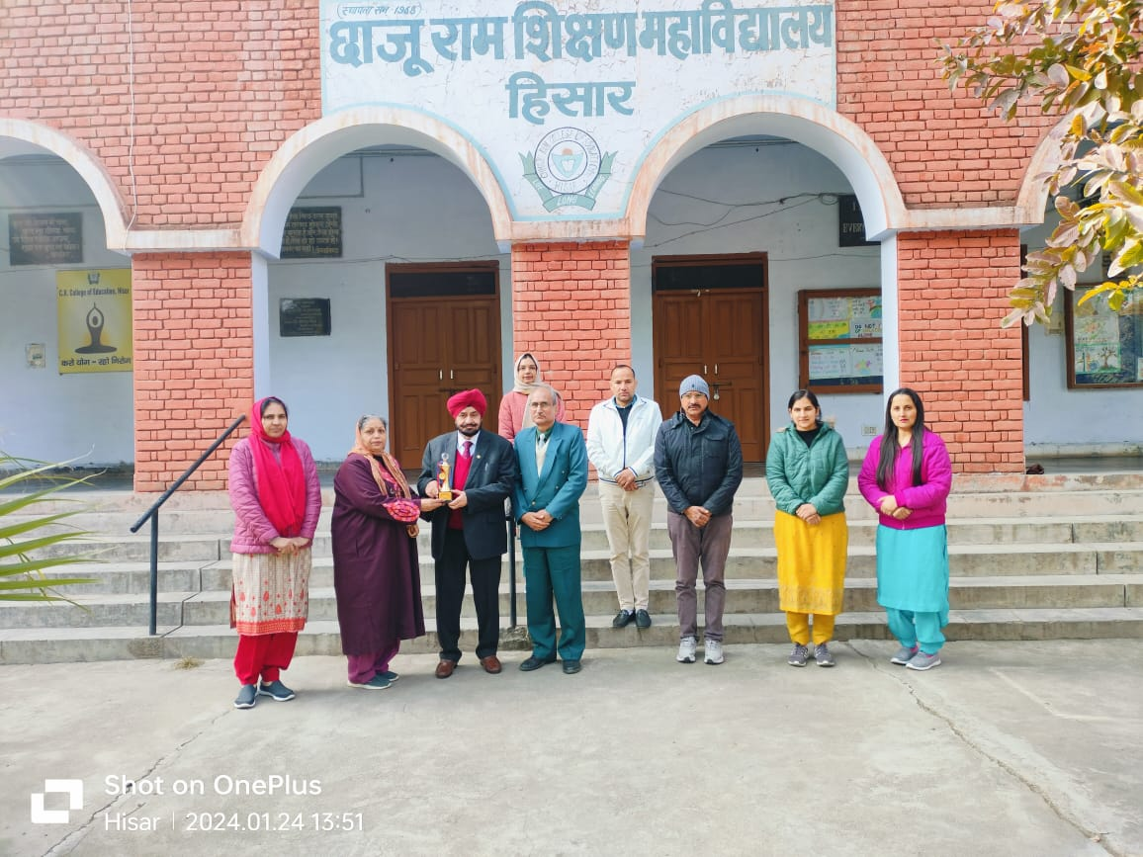

Youth Red Cross Training Camp
